
Department of SE
Software Requirement Specification
Assignment
Name: | Tahir Zaman
Roll no: | BSE-F23-M37
Date Performed | 09/08/2025
Instructors | Sir Asif Raza

Online Food Ordering System:

Use Case Diagram:

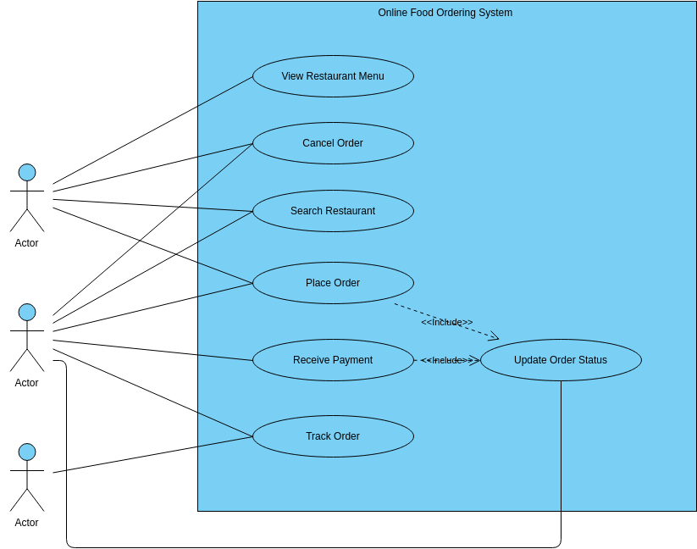

USE CASE DESCRIPTIONS

UC-01: View Restaurant Menu
Description: Customer views available food items from a restaurant.
Preconditions: Restaurant must be active and have a menu in the system.
Postconditions: Menu items are displayed.
Success Scenario:
• Open the app/website
• Select a restaurant
• View list of dishes with prices
Extensions:
✧ Menu not available
✧ Internet connection lost
Frequency of Use: Very High
Status: Completed
Owner: Frontend Developer
Priority: High

UC-02: Cancel Order
Description: Customer cancels an order before it is prepared/delivered.
Preconditions: Order must be placed and in cancellable status.
Postconditions: Order status updated to “Cancelled” and refund initiated if applicable.
Success Scenario:
• Log in to account
• Go to 'My Orders'
• Select order and click “Cancel”
Extensions:
✧ Order already dispatched
✧ Cancellation time window expired
Frequency of Use: Occasional
Status: In Development
Owner: Backend Developer
Priority: Medium

UC-03: Search Restaurant
Description: Customer searches for restaurants by name, location, or category.
Preconditions: User is on the search page.
Postconditions: List of restaurants matching criteria displayed.
Success Scenario:
• Enter search keyword
• Apply filters (e.g., cuisine type)
• View restaurant results
Extensions:
✧ No results found
✧ Invalid filter
Frequency of Use: High
Status: Completed
Owner: Frontend Developer
Priority: High

UC-04: Place Order
Description: Customer selects items from menu, adds to cart, and places the order.
Preconditions: Customer must be logged in.
Postconditions: Order placed and status updated.
Success Scenario:
• Select restaurant
• Add items to cart
• Confirm delivery address and time
• Click 'Place Order'
Extensions:
✧ Cart empty
✧ Payment gateway error
Frequency of Use: Frequent
Status: In Development
Owner: Full Stack Developer
Priority: Critical

UC-05: Receive Payment
Description: System receives payment for an order (COD, card, digital wallet).
Preconditions: Order must be placed.
Postconditions: Payment confirmed and order status updated.
Success Scenario:
• Select payment method
• Complete payment
• Receive payment confirmation
Extensions:
✧ Payment failed
✧ Payment gateway timeout
Frequency of Use: Frequent
Status: Ongoing
Owner: Payment Integration Developer
Priority: High

UC-06: Track Order
Description: Customer tracks delivery status in real-time.
Preconditions: Order must be placed.
Postconditions: Live status displayed.
Success Scenario:
• Go to 'Track Order' section
• View current delivery stage (preparing, dispatched, delivered)
Extensions:
✧ GPS tracking unavailable
✧ Order status not updated
Frequency of Use: Occasional
Status: Pending
Owner: Backend + Support Developer
Priority: Medium

UC-07: Update Order Status
Description: System updates order status after payment or order placement.
Preconditions: Order exists in system.
Postconditions: Order status changes in customer and admin views.
Success Scenario:
• Order placed → status set to “Preparing”
• Order shipped → status set to “Out for Delivery”
• Order delivered → status set to “Completed”
Extensions:
✧ Status update failed
✧ System crash
Frequency of Use: Automatic on every order
Status: Ongoing
Owner: Backend Developer
Priority: High

